FACT SHEET MAY 2019
WHY IS FERTILIZER PLACEMENT SO IMPORTANT?
More Hidden Secrets – PLACING TO MEET PLANT FUNCTION
by: Mike Petersen, Soil Scientist/Agronomist for Orthman Manufacturing, Inc
As we at Orthman Manufacturing have learned and studied root systems for over two decades, we would like to pass some good news along to you. Speaking specifically of maize, the young plant root system develops and thrives in the presence of nutrients. It does not seek nutrients it is more of a fashion of running into the nutrients that dissolves into the soil solution. It is important to also know that aerobic soil bacteria are doing the lion’s share of converting nutrients like N, P, K, Zn, S, B and others into the root and then they are pumped up into the leaves and eventually the fruiting body. So where we place it with the implement of the 1tRIPr or nutrient toolbar has a huge impact for higher yield potentials.
Knowing when a few of the important physiological states of the maize plant exists in its short lifespan of 120+ days; soil temperature, heat units and moisture in the upper aerobic portion of the root zone we can properly place nutrients to supply the growth and yes, the yield. I will explain as best as possible.
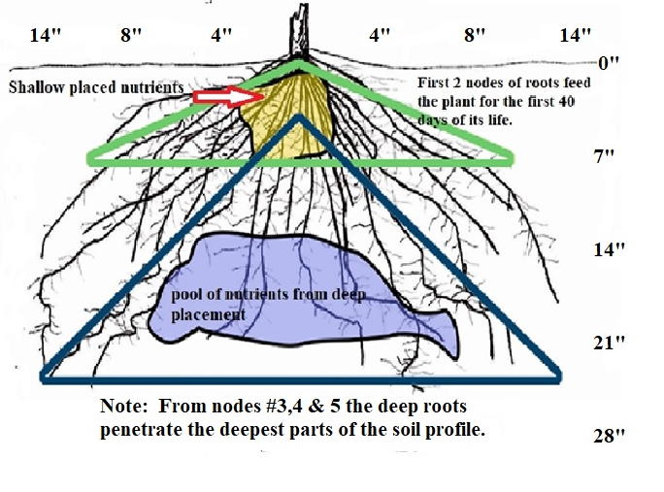
Figure 1. Diagram of maize root system at approximately 50 days after emergence
Nitrogen – Just for a moment: In the first 25-40 days of the young maize plants life it only consumes about 12 to 14lb/acre of N. Yes that is all. That is in the Ammonium (NH₄) form for the first 15 days then the plant switches over to predominantly nitrate (NO3) form – nearly all of this comes from the upper 6 inches of the soil profile.
Phosphorus (P) has very minor amount of P right at emergence, then bigger need between 35 to 50 days after emergence (DAE) mist likely 50-66% of the plants season needs. Then right at the silking stage which is R1-R2. Phosphorus is needed throughout the first 70 days yet at the R2 stage when the plant is putting sugars and carbohydrates into each kernel having P in the soil at depths of 6 to 12 inches is very wise.
Potassium (K) is needed at emergence, then at 45-55 DAE then again around the R2 stage. So potassium in and around the seed placement to begin with has a lot to do with placement as well as deeper (6 to 12 inches) for later. Why? The roots are growing and becoming prolific at that depth and deeper as well as the third, fourth node of roots in the root crown are developing and being pulled by gravity deep. It is our suggestion that applying P & K at depth (6 to 8 inches below the soil surface) is premium to crop growth.
Secondary and Micronutrients: Sulfur (S) does not have much of a call by the roots until 50DAE and then at pollination then at the R2-R3 stages. Total need is around the 12 to 25lbs/acre. The micronutrients of Boron (B), zinc (Zn), Manganese (Mn), Iron (Fe), Copper (Cu) all of these are needed early; before the 45DAE time frame. Zinc plays a huge companion role with phosphorus so at the 50 DAE period we must be mindful of that. Boron is taken up easily but moves very slow within the different tissues of the plant and needs to be available long before the genetic need says “Now!”
Ideas of N Timing: We have not said much about Nitrogen and when it is needed yet. When we see the recent trends in nitrogen fertilization and thinking of how the plant calls for N, placement and timing is very important. The first application of N that makes a good deal of sense is pre-plant. Placing N below the seed at depth of 4 to 7 inches fits the plants demands. If possible in your management plan applying N next at V3 to V5 stage the plant is ready to establish the number of rows of kernels around the cob. To state the obvious – Very Important! Then if possible at V7-V8 stage, ‘sidedress’ as it has been called in the States. Next significant time is when the plant is 70-75DAE the time it is determining the length of the cob of kernel number from butt of the ear to the tip – this is optional. The last very smart time to apply N (it too is optional) to apply N at the R2 stage when the silk has turned pink and going to red. Our Orthman studies have demonstrated a solid boost in kernel weight and that could be 3 to 21bu/acre improvement in yield. All of these times may not work for you, but to think about how to set up the plants potential is a detail we at Orthman want you to have to reach higher and sustainable production.
All of these suggested options can be specific to your soils, existing soil test levels, desires for yield, rainfall and timing. Along with the diagram to illustrate the root system, application locations - We want to help you see the benefits of timing, placement and using the right products for your farm. This is never a “one size fits all” approach. Optimally we feed the plant like you feed a hungry teenage boy. But that is all the time, yes?
We at Orthman are here to make it happen; we like to “Get to Work with You”.
Orthman Manufacturing, Inc
2019

